Western Region U16 Championships
March 21st-March 24th, 2023

Discipline: SG Race, SL, GS & SG Championship Races

Eligible Racers: U16 Athletes- Qualifications Per Western Region Rules

Venue: Sun Valley Resort
SL on Warm Springs
SG & GS on Greyhawk-Hemingway (Race Country)

Schedule: Saturday March 18th- Training Space Available at Rotarun
Sunday March 19th- Training Space Available at Rotarun
- Contact Riley@rotarun.org for pricing & scheduling
Monday March 20th-
Event Registration at 9am- Greyhawk Yurt
- Lift Ticket Pick-Up
- Swag Bag
SG Hill Freeski Starting at 10am
Tuesday March 21st- Girls & Boys SG Race
Wednesday March 22nd- Girls & Boys SG Champ Race
Thursday March 23rd- Girls GS, Boys SL
Friday March 24th- Girls SL, Boys GS

Entry Fee: $54 per Super-G race, $50 per SL/GS plus $35 Souvenir
Series Fee: $243

Entry Deadline: Tuesday, March 14th (seven days prior to the first team captains’ meeting). Entries to be submitted via a divisional entry form, including the coaches roster indicating who needs coaches tickets. Payments for entries to be arranged with the Divisional Managers. Email entries to: raceadmin@svsef.org

Seeding: The seeding matrix will be filled out by the Divisional Managers.

Lift Tickets: Athlete Passes are $280 for the series (including freeski day). Team Captains will pick tickets up at the Greyhawk Yurt the morning of March 20th (before Hill Freeski) Divisional payment required.
For teams arriving early, tickets will be available at the WS Ticket Office for $56/per day. Roster must be submitted 3 days prior to arrival.
Parent tickets available at the WS Ticket Office for $95/per day

Waiver: https://forms.gle/Hax5m8LTpBjs4tCx8

Bibs: Athletes will turn in bibs at the finish each day, new bibs will be issued at the TC Meeting each day.

Chief of Race: Will Brandenburg (208) 481-7269
Race Administrator: raceadmin@svsef.org
TD: Gil Denis

Team Captain’s Mtg: Monday, March 20th, 2023 at 4:00pm at the SVSEF Training Center, 215 Picabo St (above Apple’s). All competitors must be represented.

Race Communication: Via WhatsApp- Coaches will be provided link.

Awards: Banquet to be held on Mar 23rd at the Limelight Room in Sun Valley. Divisional Managers must pay and reserve athlete and coach space prior to arrival, more info to come.
Overall & Final Day Awards 30 Mins After Protest Period at the Warm Springs Base Area
Unofficial times available on Live Timing.
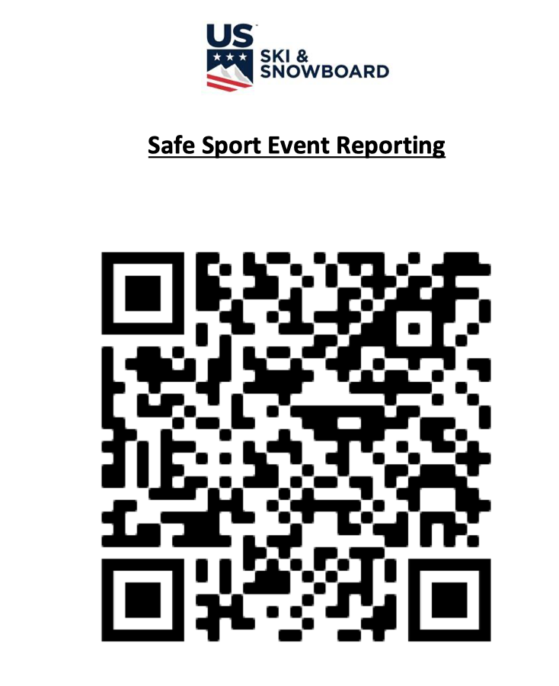

Athletes needing to report any safe sport violations during or after this event, please use above QR code.

